Circulation: | NFU North East, NFU East Midlands, NFU West Midlands, NFU Policy Services, CallFirst, NFU Comms. |  | Date: | 9th January 2020
 |  |  | Ref:
 |  |  | Contact: | Mhari Barnes  Richard Wordsworth

Extension of Farming Recovery Fund

This briefing provides updated information on the Farming Recovery Fund following the briefing issued on 25 September 2019. Please discard the September briefing and use this one until informed otherwise.

Overview

Defra and the RPA have re-launched the Farming Recovery Fund with an additional £2 million to support flood-hit farmers in parts of South Yorkshire, Gloucestershire and the Midlands, including areas within Lincolnshire, Derbyshire, Nottinghamshire and Worcestershire.

The Farming Recovery Fund first opened in September 2019 with £2 million available to support farmers affected by flooding in the Reeth area of North Yorkshire and Wainfleet in Lincolnshire over the summer. The announcement on the 6th January brings the total funding available up to £4 million, to help affected farmers get back on their feet. Defra confirm that the £4m is the maximum available across all eligible farmers, and not ring fenced to the original and now new extended areas. It should also be noted that the RPA will process the claims in order of receipt and given there is limited funds that could have a bearing if a lot of applications are received to the success of a late submitted application.

The fund will provide support to farmers who suffered uninsurable damage to their property in the devastating floods in November 2019. During the heavy rainfall events there was significant overtopping of flood defences and breaches in river banks which lead to thousands of acres of agricultural land being inundated with flood water for weeks.

Grants are available between £500 and £25,000 to cover a number of repair costs, including removing debris, re-cultivation and replacing damaged field gates. This scheme provides a contribution to the uninsured losses incurred by eligible farmers.

Farmers who have already repaired damage caused by the flooding should keep records of all relevant evidence, including receipts and before and after photos, in order to help the RPA process eligible applications promptly.

New Handbook

An updated Farming Recovery Fund handbook (the handbook) has been published on 6th January on gov.uk with full details of which areas are eligible and within some areas what events would need to have occurred to be eligible, what items are covered and how to apply for funding. We would urge all famers in the identified areas to read this handbook carefully. The RPA state the following in relation to whether a farmer in the Reeth or Wainfleet area should read the new handbook or not:

The handbook and application form have been updated. They now include a new reference cost for cover crops and more advice on making your application. If you have used a previous version of the handbook, you should read the updated version. If you have already applied to the fund, call the Rural Payments Agency helpline on 03000 200 301 for more information.

It is important to note that whilst most of the scheme requirements remain the same as set out in the original handbook, the new updated handbook has been rewritten or rearranged in places and some new supporting information has been included. It is however, important to note that there are different deadlines for the original and new areas to apply and claim monies which are clearly set out within the handbook and these prevail over and above the changes in guidance for the original handbook.

NFU Activity

Although the Farming Recovery Fund was launched back in September 2019 for members affected in Wainfleet and Reeth, the NFU has continued discussions with the RPA regarding potential amendments to the handbook and has hosted information meetings for members. The NFU remains in discussions with the RPA over member meetings for this extension of the Farming Recovery Fund and we will provide more detail on these in the near future. The work of the NFU has led to a number of critical improvements to the original approach that was going to be taken by RPA / Defra.

Areas Not Currently Covered by the Scheme

East Yorkshire
Although not currently included, the NFU is also making a case for flood-hit areas in East Yorkshire to be included in the scheme as the River Hull (Beverley and North Holderness Internal Drainage Board), Winestead Drain (South Holderness Internal Drainage Board), River Idle and Torne (Doncaster East Internal Drainage Board) who have all suffered significant flooding from overtopping. The RPA is looking into this with the Environment Agency to determine whether this area is eligible.

Herefordshire
There has also been concerns raised by farmers in Herefordshire who have not been included in the scheme, the NFU is currently looking into this in more detail. However, it is important to reiterate that the Farming Recovery Fund is a contribution to cover uninsurable losses to those who have suffered from an exceptional event. In order to determine this, the RPA has worked with the EA on deciding the eligible areas and asked the IDBs to draw up the maps. However, it’s important to note that even if a farmer is within the boundaries of the maps provided, it does not necessarily mean that they are eligible unless the EA have stipulated that you have flooded from overtopping of flood defences or a breach of a flood defence.

Eligibility Conditions within the New Eligible Areas

Due to the widespread flooding that occurred in November the RPA was struggling to decide how to determine the areas that would be eligible as it had to state that it was an ‘exceptional event’ so that the scheme complies with state aid rules.

As it currently stands, the eligible criteria as stipulated in the updated handbook is as follows: the flooding of low lying agricultural land by overtopping of rivers and the breaches on Barlings Eau, Dorrington and Timberland Delph watercourses on 7th and 8th November 2019 within the Internal Drainage Board areas of Ancholme, Scunthorpe and Gainsborough, Witham Third, Upper Witham, Trent Valley and Danvm. A map of the Internal Drainage Board areas is provided in the handbook. For South Yorkshire, Nottinghamshire and Lincolnshire, satellite data is available that provides an indication of the flooded agricultural land that is situated alongside the overtopped and breached rivers, within the relevant Internal Drainage Board areas.

Further restrictions are in place for the flooding of agricultural land by overtopping of flood defences on the Derbyshire Derwent and Dove and the Avon in Worcestershire and Gloucestershire, downstream from Evesham. For these areas, satellite data is available that provides an indication of the flooded agricultural land that is situated alongside the overtopped flood defences in the relevant river catchment areas.

If land is included in an application that was not impacted by overtopping or a breach, as set out above, it will be deemed to be ineligible and removed. Also, important to note is that if an application falls below £500 it may be rejected.

Cover Crops

One of the outcomes from the member meeting at Wainfleet was regarding cover crops. The NFU worked with the RPA after the meeting to highlight the benefits cover crops have especially with regards to improving soil quality after a period of inundation. The updated handbook has now been amended to include cover crops as a reference cost eligible claim item. However, the cover crop must be ploughed in as a green manure or destroyed and not used for profit. The applicant must also provide photographic evidence a) that the crop was planted and; b) that it was destroyed. The applicant must also not have had the intention prior to the flood event to plant cover crop under a greening EFA option, as part of the BPS.

The inclusion of cover crop option is important for those in the original Wainfleet area to be made aware of as it was not covered in the original handbook they will have looked at and so they should made away of the revised text in the updated handbook.

Increase of the Maximum Claim Cap

The initial maximum claim per farm business was £20,000 and the NFU were pleased to see that increase to £25,000 when it was launched in September 2019.

After an NFU and RPA farmer meeting in Reeth to discuss eligibility to apply for the Farming Recovery Fund, it was made apparent that some farming businesses are facing non-insurable recovery costs of more than £25,000, for one farming business (with three farms) is expecting the recovery costs to be upwards of £75,000. The NFU has raised and discussed this issue with the RPA at length. Due to state aid rules, each application is based on a farm business and their SBI number and not individual farms. The fund is also seen as a contribution and therefore not all costs of the flood event will be covered.

Interestingly, after the 2015-16 flood events which led to the 2016 Farming Recovery Fund the average claim per farm business was in the region of £8,000. It is important to note what was said when the FRF was announced, it was stated that ‘up to £2 million’ was available, meaning there is not a pot as such available.

Update: The NFU remains to make the case for an increase in the maximum claim cap. If there is any progress with this we will update you. It is however vital that affected members should continue to apply based on the current published rules to avoid missing this time limited funding opportunity.

The NFU’s Top 10 Key points

The NFU has reviewed the updated handbook and picked out some key points that should be considered in relation to the Farming Recovery Fund. As stated previously, we still recommend that all concerned should read through the handbook carefully to ensure a clear understanding of the scheme.

- Funding Basis - The £4 million funding is coming from the Treasury. The FRF will close to applications on 31st March 2020 for the original Wainfleet and Reeth areas and for the new areas in South Yorkshire, Nottinghamshire, Lincolnshire, Derbyshire, Worcestershire and Gloucestershire closing date is the 31st July 2020 see the flow charts in Appendices 1 and 2 below. The fund only covers like-for-like not betterment due to state aid legislation.
- Funding Limits – Minimum of £500, maximum £25,000 can be received. 100% of costs covered up to the value stipulated for the activities listed. Understand what is eligible and what is not. The RPA state the following when it comes to amounts over £25,000: If you have eligible costs that exceed the scheme maximum you can let us know this in your application, but we can only guarantee funding up to the scheme maximum. You must only include costs up to £25,000 in the Eligible Costs section of the Application Form.
- Application Form – This can be submitted either online or by post.
  - If submitted online the Farm Businesses’ RPA registered email address must be used and with ‘FRF 2019’ and business name in email subject box.
  - Forms will be processed quicker if submitted as an electronic copy.
  - If posting a paper form, make sure it is signed and this and any supporting documents for an online application are sent to the RPA Penrith address stated.
  - An online version of the excel sheet can work out the claim values.
  - Ensure that when completing the form it is consistent with other RPA held business data.
  - Number your evidence e.g. ‘1 of 8’ so that it’s easy for the RPA to keep track of all your evidence as well as Business name and SBI number added to it.
- Application Photographic Evidence – this is essential, RPA need to see the damage!
  - All photographic evidence must be clear and consistent with ES/CS manuals.
  - They must be labelled and dated with farm business name, SBI and field number must also be written on the back and other information asked by the RPA.
  - Remember to tie photos in with mapping to show where they have been taken from.
- Licences & Consents – this includes Flood Risk Activity Permits must be granted prior to submitting the FRF application. Failure to do so may result in the FRF being denied. Remember any agri-environmental scheme management issues. Click here for information about main and ordinary watercourses.
- Application Submissions - A dual approach is acceptable e.g. submit the electronic form and then the evidence can be submitted as a hard copy by post.
- How to apply for Funding – Three methods are open to applicants to determine this – consider the appropriate approach as set out in the handbook which has detailed information and what is required. The easiest way is to use the standard and reference costs outlined in the handbook. If using quoted costs, the quotes must be from businesses completely independent from your farm business. The updated handbook has further guidance on the requirements.
- Mapping – Use the RPA’s online mapping tool
  - RPA maps default to A4 size, use a photocopier to gain size to allow greater detail to be annotated on the maps when downloaded and printed.
  - Maps can be annotated by hand and scanned in showing details of sites where the damage has occurred and the remedial work that is required/has been carried out.
  - The updated handbook includes an example of what the RPA is looking for
- Approach to the Scheme - Manage the risk associated with timings - see the flow charts in Appendix 1 and 2 below:
  - Understand the ‘tiers’ of eligibility, firstly is the affected land within the RPA identified areas; secondly, was the damage caused by one of the events mentioned; and thirdly, what a farmer wants financial support for is not insurable but does appear on the list of eligible items and activity. Reading the handbook is essential
  - Also, understand this is a multi-staged scheme, applications, approval and confirmation of terms, carrying out works and then claiming the monies based on evidence provided, this all requires monitoring throughout
  - Bear in mind the timings required for the remedial work and proprietary work.
  - Get the application form in well ahead of the deadline as this will give you more time to complete the remedial work, especially if flood risk activity permits or environmental permits are required before the work is carried out as these may come with a timeframe of their own.
  - RPA will send a claim form to successful applicants. All the work agreed must be completed and the invoices paid as well as further mapping and photographic evidence captured showing work done before submitting the claim form.
  - Remember to continue to gather evidence and retain paperwork post acceptance for the Scheme to ensure that the claim can be made successfully. Read the claim form and associated guidance as soon as you receive it.
- Retrospective Applications – these are allowed in certain situations:
  - The handbook suggests that remedial work already commenced could be covered by the FRF, this if between the dates noted for the events in the relevant area and when the guidance was published. The requirement for appropriate permitting and consents being in place for these claims is important to understand.
  - If work has been carried out retrospectively and you are struggling to find sufficient evidence, speak to neighbours, look on social media and check out news articles for anything that may help make your case prove: 1) post flood position and 2) current position.

Further Useful Information

- When a grant funding agreement is signed and returned, the RPA will then carry out a phone call to talk through the funding agreements, any consents required and the claim process.
- RPA may carry out inspections at random to check the projects/activities carried out where successful applications were granted. This is normal under the grant funding agreement.
- The RPA will honour a ‘no-penalty’ approach but may withhold, suspend or request payback of the FRF if a grant awardee is in breach of the conditions.
- If work has been carried out retrospectively and insufficient quotes were obtained beforehand the RPA will only cover the Standard costs.
- VAT registered farm businesses must not include VAT in the total amount. Non-VAT registered can include VAT but need a recognised accountant’s letter stating that they are not VAT registered.
- Eligible areas are detailed in the maps in the handbook Appendix.
- Dedicated RPA phone line via: 03000 200 301.
- Information and advice for members available from CallFirst 03708 458 458 and NFU Online

Appendix 1

Below is a high level overview of the FRF scheme and timelines for the original Wainfleet and Reeth eligible areas, for guidance only, there is no substitute to reading the handbook.

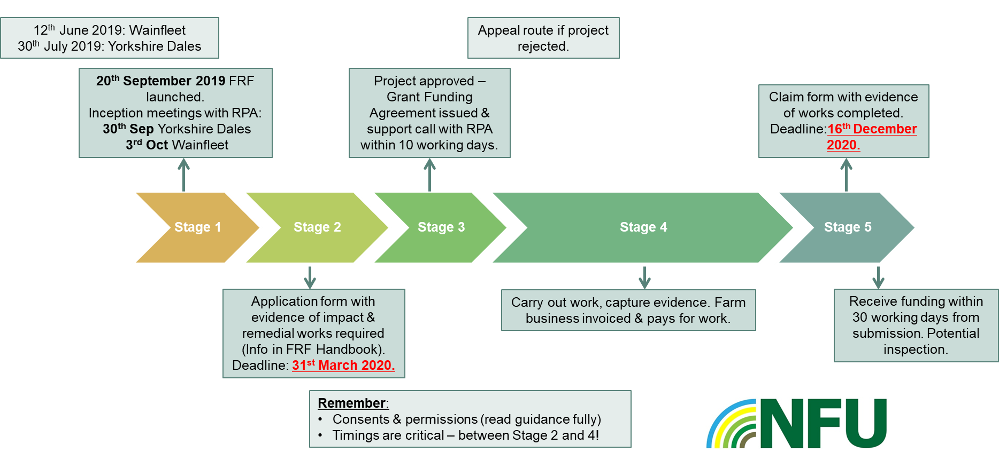

Appendix 2

Below is a high level overview of the FRF scheme and timelines for South Yorkshire, Nottinghamshire, Lincolnshire, Derbyshire , Worcestershire and Gloucestershire, for guidance only, there is no substitute to reading the handbook.

